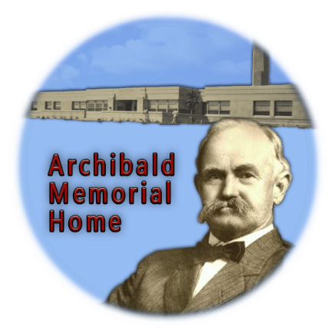
Name(s)

Email Address

Phone

Home Mailing Address

**********************************************
Membership rate is $15 / person.
Please write check payable to Archibald Memorial Home.

